api Test Automation

What is an API?
API is the acronym for Application Programming Interface, which is a software intermediary that allows two applications to talk to each other. Example: Google maps API (Uber, OLA is using google maps API), Flight booking or hotel booking websites.
OR
An API is the interface through which you access someone else’s code or through which someone else's code accesses yours. In effect the public methods and properties.
OR
API stands for Application Programming Interface through which software can interact with each other.

What is the difference between API and Web Services
All webservices are API, but all APIs are not webservices. For example calculator API can be called within a machine.
A webservice always needs a network to operate whereas APIs don’t always need a network for operation.

What is Endpoint in API?
It's one end of a communication channel, so often this would be represented as the URL of a server or service.
OR
An endpoint is a URL pattern used to communicate with an API.
/this-is-an-endpoint
/another/endpoint
/some/other/endpoint
/login
/accounts
/cart/items

and when put under a domain, it would look like:

https://example.com/this-is-an-endpoint
https://example.com/another/endpoint
https://example.com/some/other/endpoint
https://example.com/login
https://example.com/accounts
https://example.com/cart/items

Also endpoint can be different for different HTTP methods, for example:

GET /item/{id}
PUT /item/{id}

would be two different endpoints - one for retrieving (as in "cRud" abbreviation), and the other for updating (as in "crUd")

And that's all, really that simple!

HTTP methods which are commonly used to communicate with Rest API’s are
GET, POST, PUT, and DELETE
GET- The GET method is used to extract information from the given server using a given URI. While using GET request, it should only extract data and should have no other effect on the data. No Payload/Body required
How to send input data in GET?
Ans: Using Query Parameters
POST- A POST request is used to send data to the server, for example, customer information, file upload, etc. using HTML forms.

How to send input data in POST?
Ans: Using Form Parameters /Body Payload
PUT- Replaces all current representations of the target resource with the uploaded content.
DELETE- Removes all current representations of the target resource given by a URI.
Source: Naveen Auto Labs
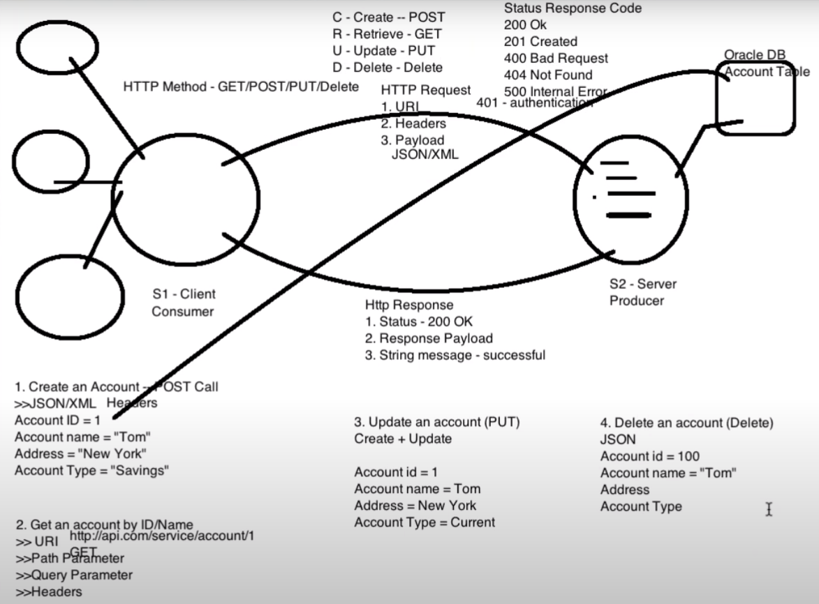
https://reqres.in
To play with API’s

What are ‘Resources’ in API?
Resources represent API/Collection which can be accessed from the Server:
Google.com/maps
google.com/search
google.com/images

Path Parameters
Path parameters are variable parts of a URL path. They are typically used to point to a specific resource within a collection, such as a user identified by ID
https://www.google.com/Images/1123343
https://www.google.com/docs/1123343
https://amazon.com/orders/112

Query Parameters:
Query Parameter is used to sort/filter the resources.
Query Parameters are identified with ”?”
https://amazon.com/orders?sort_by=2/20/2020

End Point Request URL can be constructed as below
Base URL/resource/(Query/Path)Parameters

Headers/Cookies:
Headers represent the meta-data associated with the API request and response. In layman terms, we were sending Additional details to API to process our request.
Example : Authorization details
Meta-data meaning – The data that provides information about other data

URI, URN and URL

Serialization and Deserialization of Request/ Responses with POJO (Plain Old Java Object) classes
Serialization in Rest Assured context is a process of converting a Java object into Request body (Payload)
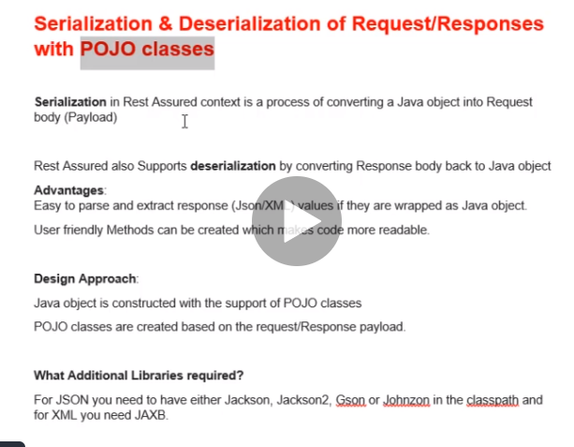

Swagger
Swagger is the tool for API documentation

Build framework

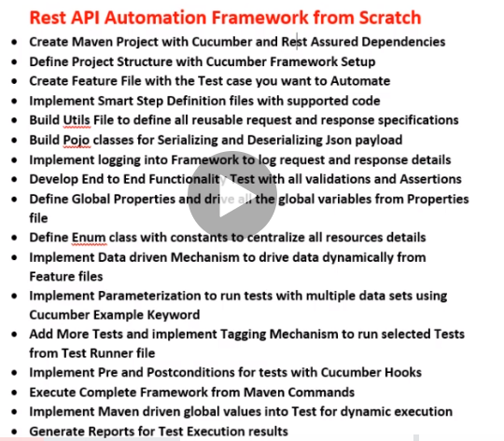
- Create a maven project and add archetypes if missing using the below steps
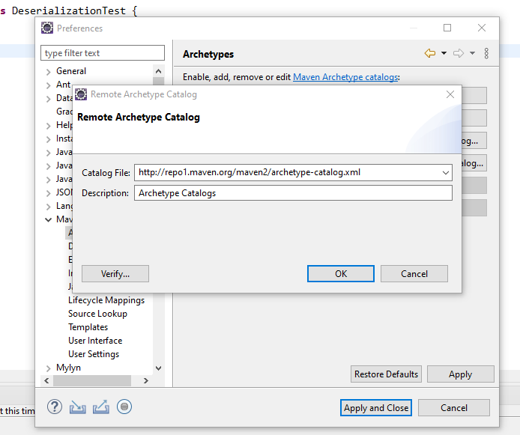

http://repo1.maven.org/maven2/archetype-catalog.xml

- Artifact id – project name
Group id – some unique id
- Use archetype
- Add Dependencies in POM file

